**How to use this site:**

**Please note:**

* **Data is provided for PICs greater than 100 ha only. The PIC data is refreshed annually.**
* **Native vegetation masking can sometimes limit the number of pixels shown**

**Select location:**

To get started choose your property by typing in the PIC or Property ID in the left hand side bar or zoom into the map and select your property by clicking on it. Once selected the property details will be shown in the left hand side bar.

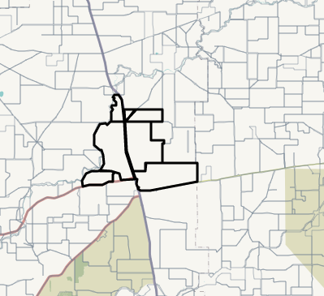

Click on the Pasture Growth tab or Feed on Offer tab to view the selected property. This screen shows the property boundaries with the latest FOO or PGR values by pixel

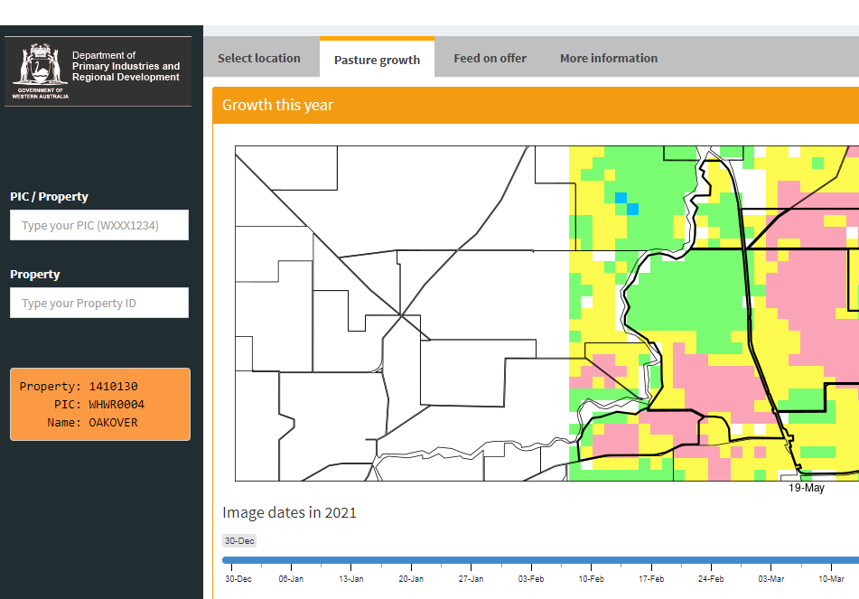

The default image shown is the current image, which is a composite of all MODIS images for that week preceeding the date shown. This is different to the state FOO and PGR map which has a naming convention of using the date at the start of the week, but contains images from that week. The blue slider bar allows you to view previous week’s images.

**Pasture growth:**

The default graph displayed below will be for the property summary, showing the decile range for all years since 2004 and the current season cumulative pasture growth. Also displayed is the closest year with a similar growth path to provide a comparison or a possible finish to the season.

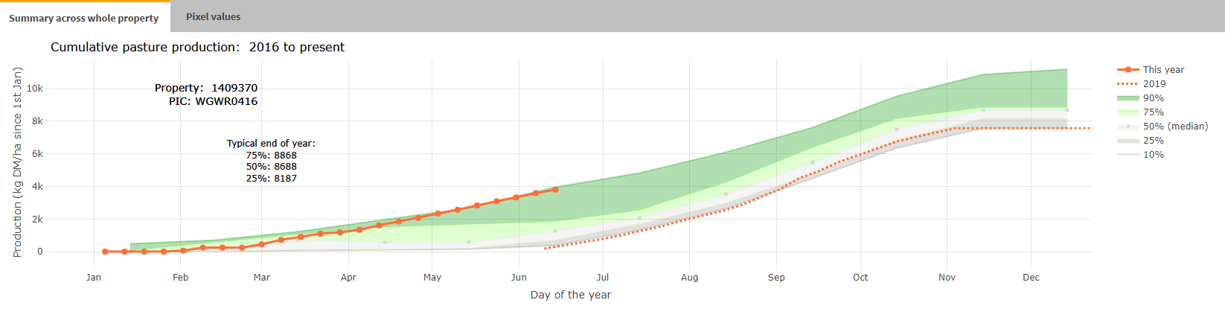

Explaining the legend:

The orange line ‘this year’ shows the growth as a cumulative PGR.

The mid green line 90% shows the pasture growth in the top 90% of years and the shading labelled ‘90%’ shows the pasture growth range in the best 75 -90% of years.

The light green line 75% shows the pasture growth in the top 25% and the shading labelled ‘75%’ shows the pasture growth in the best 50%-75% of years.

‘50%’ shows the median growth of all years – median is the middle value of all years measured.

The grey line shows the pasture growth in the worst 25% of years and the white shading labelled ‘25%’ shows the pasture growth in the lowest 25% - 50% of years.

The grey shading labelled ‘10%’ shows the pasture growth in the lowest 25% - 10% of all years.

To see a particular area within the property, choose the ‘pixel value’ tab and click on a pixel on the display above for that pixel’s current year data to be displayed.

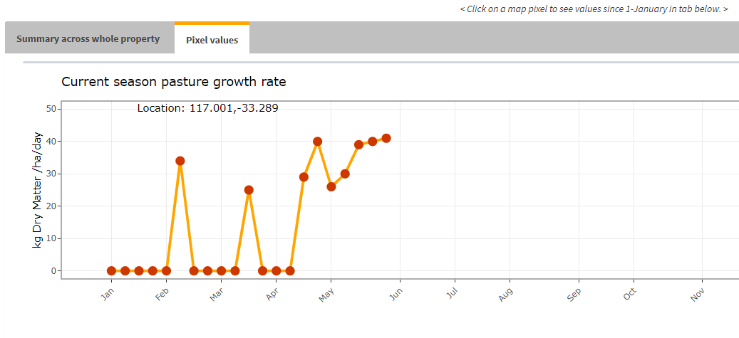

**Feed on Offer:**

Repeat the process as for Pasture Growth, selecting the Feed on Offer tab

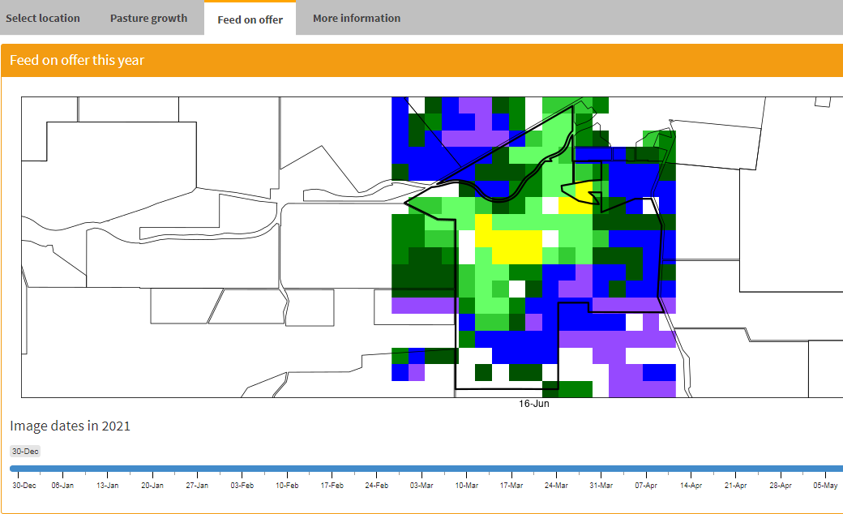

More information

[Visit the state level PGR and FOO map for the season](https://dafwa.maps.arcgis.com/apps/webappviewer/index.html?id=53c41a43783540dabca26ceb69a2ea0f)

[Understand how Feed on Offer (FOO) and Pasture Growth Rate (PGR) are calculated](https://www.agric.wa.gov.au/sheep/understanding-pastures-space-south-west-western-australia?nopaging=1)

[Learning more about feed budgeting](https://www.agric.wa.gov.au/feeding-nutrition/supplementary-feeding-and-feed-budgeting-sheep?page=0%2C0#smartpaging_toc_p0_s3_h2)

